Q1. WAP Java draw a rectangle using line.

import java.applet.*;

import java.awt.*;

public class Line extends Applet {

public void paint(Graphics g) {

// Set the color of the Line to red

g.setColor(Color.BLACK);

// Draw the Line using lines

g.drawLine(50, 50, 250, 50);

g.drawLine(50, 50, 50, 150);

g.drawLine(50, 150, 250, 150);

g.drawLine(250, 50, 250, 150);

}

public static void main(String[] args) {

Line applet = new Line();

Frame frame = new Frame("Line Applet");

frame.add(applet);

frame.setSize(300, 200);

frame.setVisible(true);

}

}

/*

<html>

<applet code=Line height=500 width=500>

</applet>

</html>

 */

OUTPUT:

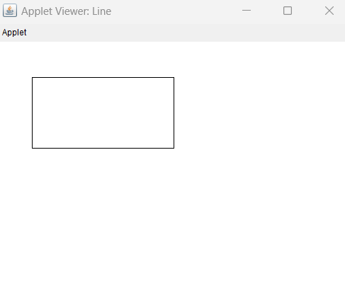

Q2. WAP Java draw a rectangle using line. Draw another rectangle inside the 1st rectangle and also display your name mid position of inside rectangle.

import java.applet.*;

import java.awt.*;

import java.awt.event.*;;

public class Rectangle extends Applet {

public void paint(Graphics g) {

int outerX = 50;

int outerY = 50;

int outerWidth = 200;

int outerHeight = 100;

g.setColor(Color.BLACK);

g.drawRect(outerX, outerY, outerWidth, outerHeight);

int innerX = outerX + 25;

int innerY = outerY + 25;

int innerWidth = outerWidth - 50;

int innerHeight = outerHeight - 50;

g.drawRect(innerX, innerY, innerWidth, innerHeight);

g.setFont(new Font("TimesRoman", Font.PLAIN, 16));

g.setColor(Color.BLUE);

String text = "Aaryak Prasad";

int textWidth = g.getFontMetrics().stringWidth(text);

int textHeight = g.getFontMetrics().getHeight();

int textX = innerX + (innerWidth - textWidth) / 2;

int textY = innerY + (innerHeight + textHeight) / 2;

g.drawString(text, textX, textY);

}

public static void main(String[] args) {

Rectangle applet = new Rectangle();

Frame frame = new Frame("Rectangle Drawing Applet");

frame.add(applet);

frame.setSize(300, 200);

frame.setVisible(true);

applet.init();

applet.start();

frame.addWindowListener(new WindowAdapter() {

public void windowClosing(WindowEvent event) {

applet.stop();

applet.destroy();

System.exit(0);

}

});

}

}

/*

<html>

<applet code=Rectangle height=500 width=500>

</applet>

</html>

 */

OUTPUT:

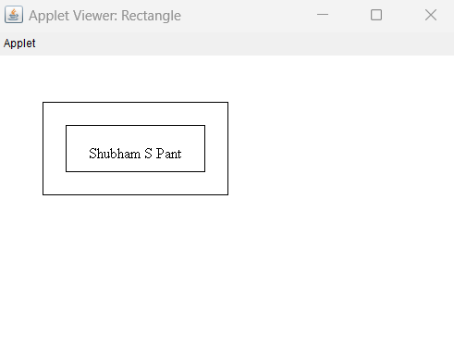

Q3. WAP Java draw Indian Flag.

import java.applet.*;

import java.awt.*;

import java.awt.event.*;

public class IndianFlag extends Applet {

public void paint(Graphics g) {

setBackground(Color.WHITE);

g.setColor(new Color(30, 136, 24));

g.fillRect(50, 50, 300, 66);

g.setColor(Color.WHITE);

g.fillRect(50, 116, 300, 66);

g.setColor(new Color(255, 153, 51));

g.fillRect(50, 182, 300, 66);

g.setColor(Color.BLUE);

int xCenter = 200;

int yCenter = 149;

int radius = 33;

for (int i = 0; i < 24; i++) {

double angle = Math.PI / 12 * i;

int x = (int) (xCenter + radius * Math.cos(angle));

int y = (int) (yCenter + radius * Math.sin(angle));

g.drawLine(xCenter, yCenter, x, y);

}

g.setColor(Color.BLUE);

int xCircle = 200 - radius;

int yCircle = 149 - radius;

int diameter = radius * 2;

g.drawOval(xCircle, yCircle, diameter, diameter);

}

public static void main(String[] args) {

IndianFlag applet = new IndianFlag();

Frame frame = new Frame("Indian Flag Applet");

frame.add(applet);

frame.setSize(400, 400);

frame.setVisible(true);

applet.init();

applet.start();

frame.addWindowListener(new WindowAdapter() {

public void windowClosing(WindowEvent event) {

applet.stop();

applet.destroy();

System.exit(0);

}

});

}

}

/*

<html>

<applet code=IndianFlag height=500 width=500>

</applet>

</html>

 */

OUTPUT:

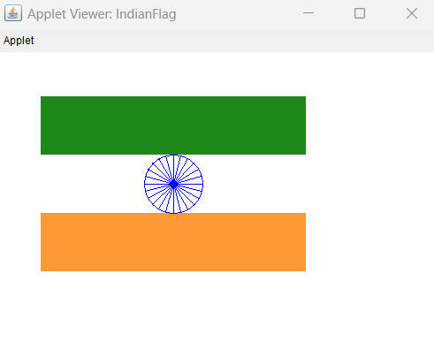

Q4. WAP Java draw a smiling face.

import java.applet.*;

import java.awt.*;

import java.awt.event.*;

public class Smile extends Applet {

public void paint(Graphics g) {

setBackground(Color.WHITE);

g.setColor(Color.YELLOW);

g.fillOval(50, 50, 200, 200);

g.setColor(Color.BLACK);

g.fillOval(90, 100, 30, 30);

g.fillOval(180, 100, 30, 30);

g.setColor(Color.RED);

g.fillArc(75, 150, 150, 80, 180, 180);

}

public static void main(String[] args) {

Smile applet = new Smile();

Frame frame = new Frame("Smile Face Applet");

frame.add(applet);

frame.setSize(300, 300);

frame.setVisible(true);

applet.init();

applet.start();

frame.addWindowListener(new WindowAdapter() {

public void windowClosing(WindowEvent event) {

applet.stop();

applet.destroy();

System.exit(0);

}

});

}

}

/*

<html>

<applet code=Smile height=500 width=500>

</applet>

</html>

 */

OUTPUT:

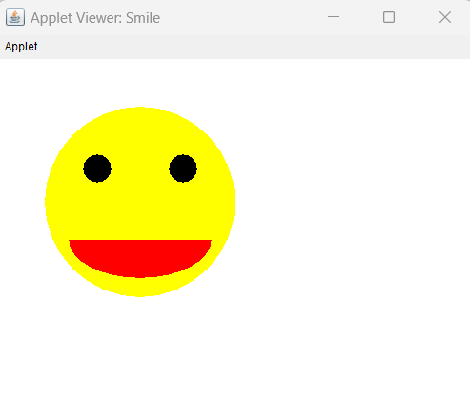

Q5. WAP Java to make a calculator.

import java.awt.*;

import java.awt.event.*;

import javax.swing.*;

public class Calculator extends JFrame implements ActionListener {

private JTextField displayField;

private JButton[] buttons;

private String[] buttonLabels = { "1", "2", "3", "+", "4", "5", "6", "-", "7", "8", "9", "*", "0", ".", "=", "/" };

private double currentTotal = 0.0;

private String currentOperator = "";

public Calculator() {

super("Calculator");

setDefaultCloseOperation(JFrame.EXIT_ON_CLOSE);

setSize(250, 250);

setLayout(new BorderLayout());

displayField = new JTextField();

displayField.setEditable(false);

add(displayField, BorderLayout.NORTH);

JPanel buttonPanel = new JPanel();

buttonPanel.setLayout(new GridLayout(4, 4));

buttons = new JButton[buttonLabels.length];

for (int i = 0; i < buttonLabels.length; i++) {

buttons[i] = new JButton(buttonLabels[i]);

buttons[i].addActionListener(this);

buttonPanel.add(buttons[i]);

}

add(buttonPanel, BorderLayout.CENTER);

setVisible(true);

}

public void actionPerformed(ActionEvent e) {

String buttonText = ((JButton) e.getSource()).getText();

if (buttonText.equals("+")) {

currentTotal = Double.parseDouble(displayField.getText());

currentOperator = "+";

displayField.setText("");

} else if (buttonText.equals("-")) {

currentTotal = Double.parseDouble(displayField.getText());

currentOperator = "-";

displayField.setText("");

} else if (buttonText.equals("*")) {

currentTotal = Double.parseDouble(displayField.getText());

currentOperator = "*";

displayField.setText("");

} else if (buttonText.equals("/")) {

currentTotal = Double.parseDouble(displayField.getText());

currentOperator = "/";

displayField.setText("");

} else if (buttonText.equals("=")) {

if (currentOperator.equals("+")) {

currentTotal += Double.parseDouble(displayField.getText());

} else if (currentOperator.equals("-")) {

currentTotal -= Double.parseDouble(displayField.getText());

} else if (currentOperator.equals("*")) {

currentTotal *= Double.parseDouble(displayField.getText());

} else if (currentOperator.equals("/")) {

currentTotal /= Double.parseDouble(displayField.getText());

}

displayField.setText("" + currentTotal);

} else {

displayField.setText(displayField.getText() + buttonText);

}

}

public static void main(String[] args) {

new Calculator();

}

}

OUTPUT:

